Docker Metadata & Labels

Step 1: Docker Containers

Labels can be attached to containers when they are launched via docker run. A container can have multiple labels attached to them at any one time.

Notice in this example, because we're using the labels for use with the CLI, and not an automated tool, we're not using the DNS notation format.

Signal Labels:

To add a single label you use the *l =<value>* option. The example below assigns a label called user with an ID to the container. This would allow us to query for all the containers running related to that particular user.

docker run -l user=12345 -d redis



External File

If you're adding multiple labels, then these can come from an external file. The file needs to have a label on each line, and then these will be attached to the running container.

This line creates two labels in the file, one for the user and the second assigning a role.

 echo 'user=123461' >> labels && echo 'role=cache' >> labels

The *--label-file=<filename>* option will create a label for each line in the file.

docker run --label-file=labels -d redis



Step 2: Docker Images

Labelling images work in the same way as containers but are set in the *Dockerfile* when the image is built. When a container has launched the labels of the image will be applied to the container instance.

Single Label

Within a *Dockerfile* you can assign a label using the LABEL instruction. Below the label *vendor* is created with the name Scrapbook.

LABEL vendor=Katacoda

Multiple Labels

If we want to assign multiple labels then, we can use the format below with a label on each line, joined using a back-slash ("\"). Notice we're using the DNS notation format for labels which are related to third party tooling.

LABEL vendor=Katacoda \ com.katacoda.version=0.0.5 \ com.katacoda.build-date=2016-07-01T10:47:29Z \ com.katacoda.course=Docker

Step 3: Inspect

Labels and Metadata are only useful if you can view/query them later. The first approach to viewing all the labels for a particular container or image is by using docker inspect.

Container:

By providing the running container's friendly name or hash id, you can query all of it's metadata.

docker inspect rd

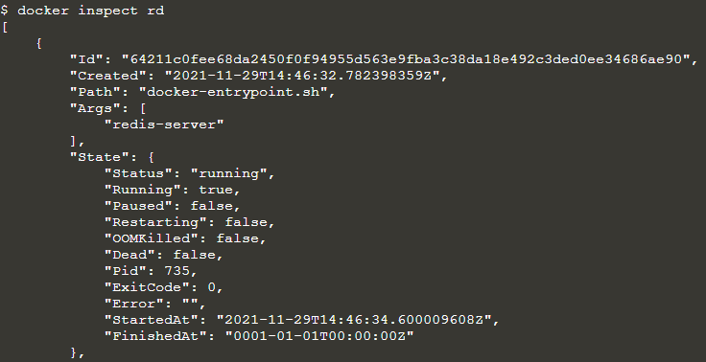

Using the *-f* option you can filter the JSON response to just the Labels section we're interested in.

docker inspect -f "{{json .Config.Labels }}" rd



Image

Inspecting images works in the same way however the JSON format is slightly different, naming it *ContainerConfig* instead of *Config*.

docker inspect -f "{{json .ContainerConfig.Labels }}" katacoda-label-



These labels will remain even if the image has been untagged. When an image is untagged, it will have the name *<none>*.

Step 4: Query By Label

While inspecting individual containers and images provides you with more context, on a production running potentially thousands of containers, it's useful to limit the responses to the containers you're interested in.

Filtering Containers

The docker ps command allows you to specify a filter based on a label name and value. For example, the query below will return all the containers which have a *user* label key with the value *katacoda*.

docker ps --filter "label=user=scrapbook"



Filtering Images

The same filter approach can be applied to images based on the labels used when the image was built.

docker images --filter "label=vendor=Katacoda"



Step 5: Daemons Labels

Labels are not only applied to images and containers but also the Docker Daemon itself. When you launch an instance of the daemon, you can assign it labels to help identify how it should be used, for example, if it's a development or production server or if it's more suited to particular roles such running databases.

We'll explore more about customising Docker's configuration and how labels are used in future scenarios, but as a taster, the syntax is below.

docker -d \

-H unix:///var/run/docker.sock \

--label com.katacoda.environment="production" \

--label com.katacoda.storage="ssd"